**Project Design Phase- II Data Flow Diagram & User Stories**

| Date | 15 October 2022 |
| --- | --- |
| Team ID | PNT2022TMID04174 |
| Project Name | Industry-Specific Intelligent Fire Management System |

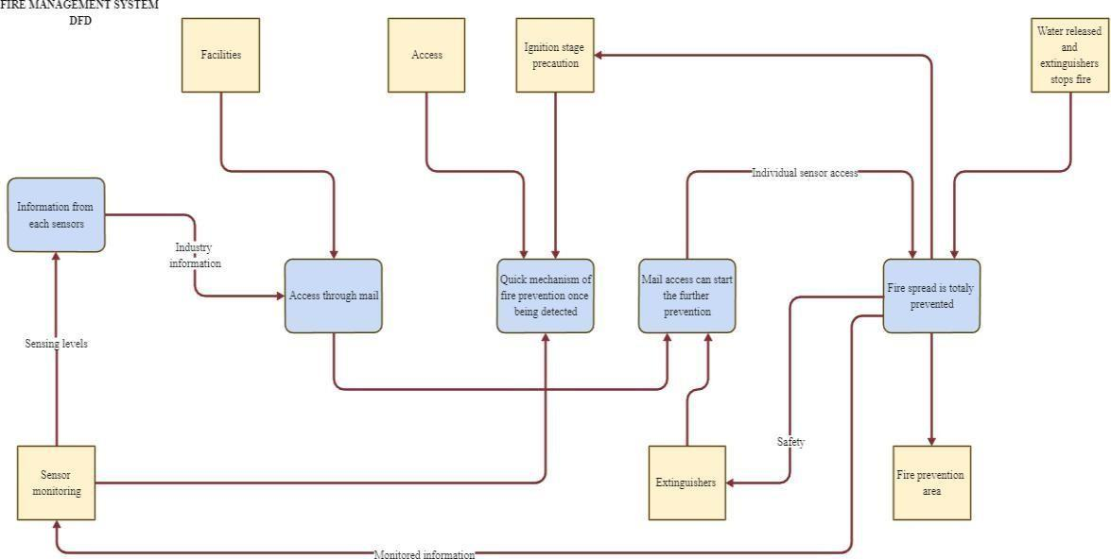

**User Stories**

| **User Type** | **Functional requirement** | **User story number** | **User story/task** | **Acceptance criteria** | **Priority** | **Release** |
| --- | --- | --- | --- | --- | --- | --- |
| Customer | Registration | USN-1 | As a user, I | I can access | High | Sprint-1 |
| (Mobile user, | can register | my account/ |
| Web user, | for the | dashboard |
| Care | application |  |
| executive, | by entering |  |
| Administrator) | my mail, |  |
|  | password, |  |
|  | and |  |
|  | confirming |  |
|  | my |  |
|  | password |  |
|  |  | USN-2 | As a user, I | I can receive | High | Sprint-1 |
| will receive | confirmation |
| confirmation | email & click |
| email once I | confirm |
| have |  |
| registered |  |
| for the |  |
| application |  |
|  | Dashboard | USN-3 | As a user, I | I can register | Low | Sprint-2 |
| can register | & access the |
| for the | dashboard |
| application | with Internet |
| through | login |
| internet |  |
|  |  | USN-4 | As a user, I | I can confirm | Medium | Sprint-1 |
| can register | the |
| for the | registration in |
| application | Gmail |
| through |  |
| Gmail |  |
|  | Login | USN-5 | As a user, I | I can login | High | Sprint-1 |
| can log into | with my id |
| the | and password |
| application |  |
| by entering |  |
| email & |  |
| password |  |